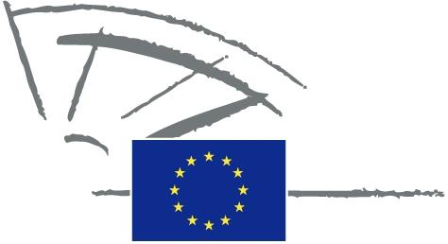
 | EUROPEAN PARLIAMENT | 2009 - 2014

<Date>{12/09/2011}12.9.2011</Date> <NoDocSe>0037/2011</NoDocSe>
<TitreType>WRITTEN DECLARATION</TitreType>
<TitreRecueil>pursuant to Rule 123 of the Rules of Procedure</TitreRecueil>
<Titre>on the establishment of the Pact of Islands as an official European initiative</Titre>
<Depute>Spyros Danellis, Maria Da Graça Carvalho, Kyriakos Mavronikolas, Alyn Smith, Giommaria Uggias </Depute>
Lapse date: <DateForclusion>{15/12/2011}15.12.2011</DateForclusion>

0037/2011
Written declaration on the establishment of the Pact of Islands as an official European initiative
The European Parliament,
– having regard to Rule 123 of its Rules of Procedure,
A. whereas islands are highly dependent on imported fossil fuels, facing higher fuel costs, but are also an opportunity for research, demonstration and development of renewable energies and energy efficiency actions,
B. whereas islands are vulnerable to climate change because of their high levels of biodiversity and fragile ecosystems,
C. whereas renewables are in abundance and their development can have a significant impact on alleviating islands’ permanent structural handicaps, providing socio-economic benefits to their inhabitants,
1. Congratulates the communities and peripheral regions that have signed the Pact with the aim of going beyond the objective of the EU 2020 Strategy, reducing CO2 emissions in their respective territories by at least 20%;
2. Calls on the Commission to continue providing its support to European island communities with a view to achieving the sustainability objectives of the EU;
3. Insists on the presence of distinctive and explicit references to insular sustainability in the EU framework programmes and policy texts in keeping with Article 174 of the Treaty on the Functioning of the EU;
4. Insists that incentives are created for all islands to adhere to the Pact and participate in islands’ networking;
5. Underlines the necessity of mobilising the appropriate financial resources to support the functioning of the Pact process, based on the model of the Covenant of Mayors, Smart Cities and other similar EU initiatives;
6. Instructs its President to forward this declaration, together with the names of the signatories, to the Commission.

